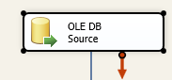

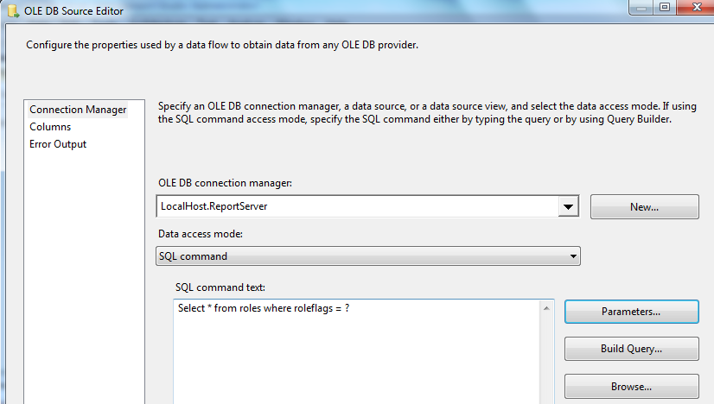

Select \* from roles where RoleFlags = ?

Click Parameters and select variable User::Roles

